Electronic Retrieval of Criminal and Civil Traffic Court Appearance Records
for
Private Attorneys

Overview
Criminal court appearance records and related documents are now available for viewing, downloading, and printing from ClerkNet by registered users with an associated bar #.

Instructions
- Log into ClerkNet as a registered use with your login/password.
- Navigate to Case Lists -> Court Appearance Record – Attorney.
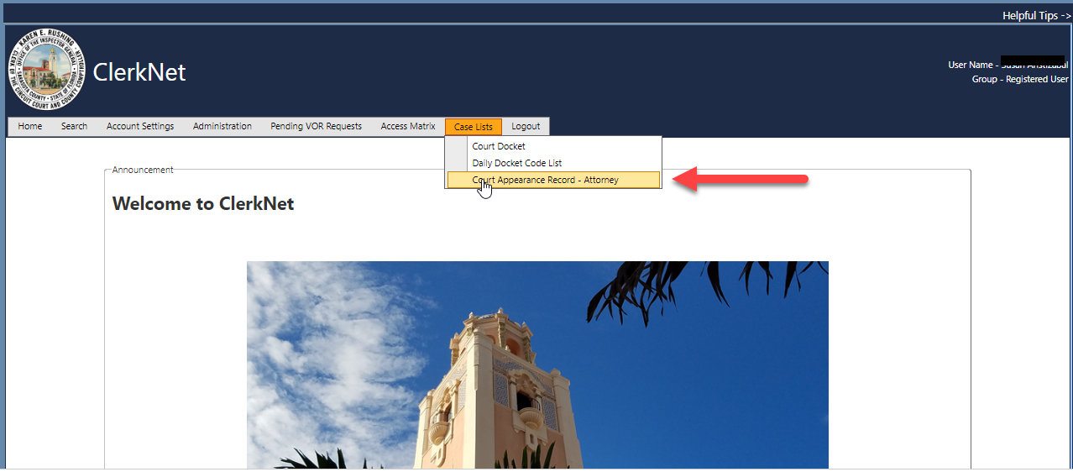

- Select Event Start Date and To Date from the drop-down fields and click the “Search Date Range” button. By default the current date is selected with corresponding docket entries displayed.
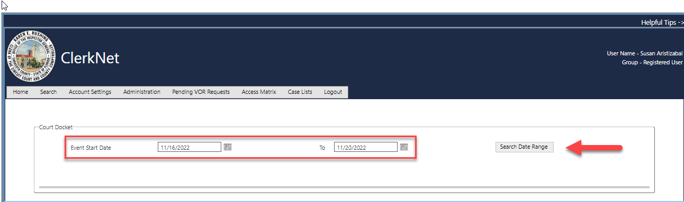

- To refine the results, you may select a specific Judge and/or an Event Type from the corresponding drop-down fields and then click “Apply Filter”. All cases displayed have the registered user designated as an attorney of record on the case.
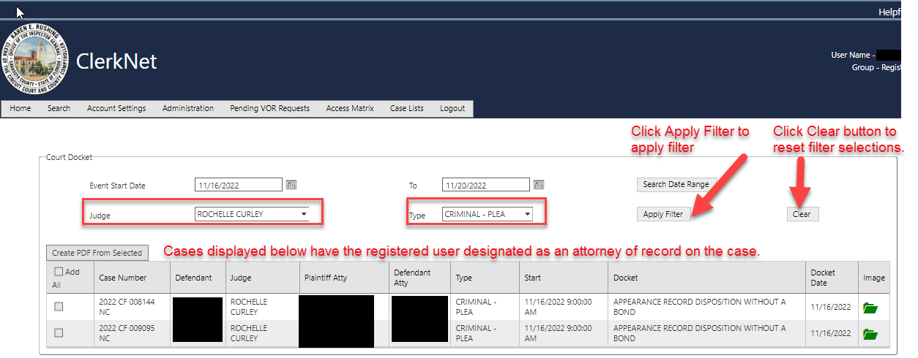

- To order the data in ascending/descending order, just click on the column that you would like to sort by.
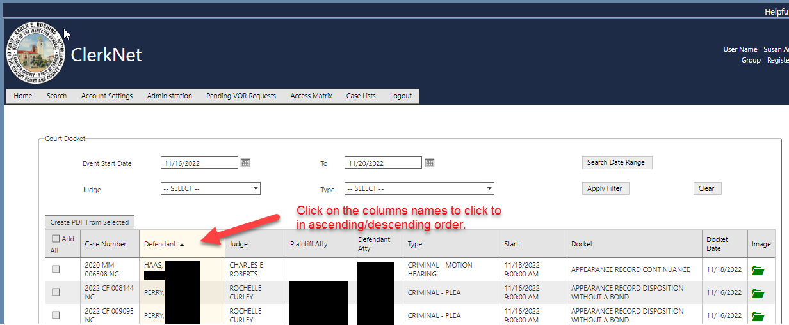
- To view a single document, click on the associated green folder icon next to the docket line.
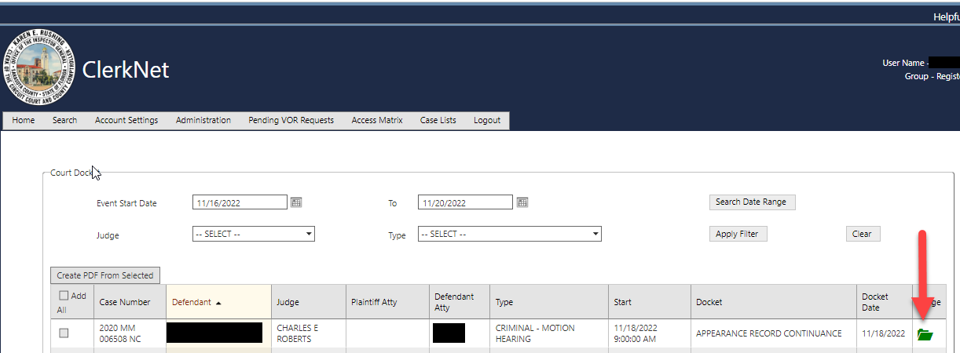

- The selected document will be displayed as a PDF in a separate browser tab. From this tab, you can view the document, print it, or download as a file as shown below.
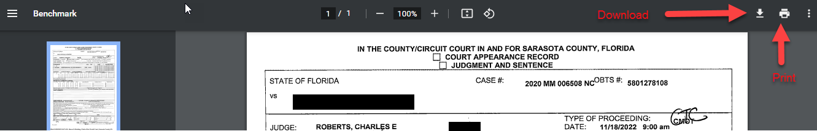

- If you would like to download multiple documents to a PDF from the filtered search results, check on the box next to the desired docket lines or check “Add All”. Then click on “Create PDF From Selected” as shown below.
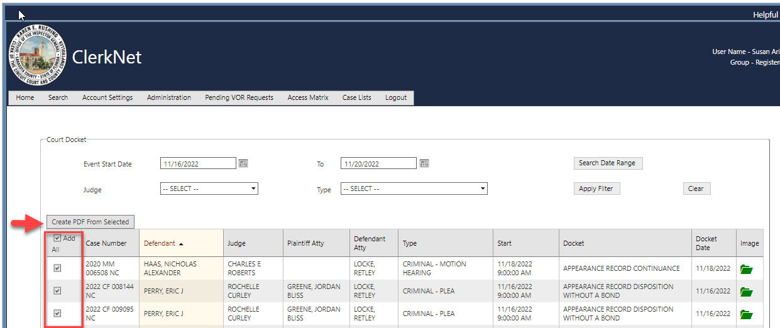
- All selected documents will be displayed together as one PDF document in a separate browser tab. From this tab, you can view the document, print it, or download as a file as shown below.

